Section 1 (Attempt any 2 Questions OUT OF 3) Total Marks 40
Problem #1 Total Points 20 (10) points for each sub part
A. For the given activities determine:
1. Calculate expected time, variance and standard deviation for each activity.
2. Design the critical path with EF and LS and slack mentioned on each activity clearly using PERT and total expected duration and variance in days of critical path
3. Calculate the probability of completing the project in 26 days.
Activity | t_{o} | t_{m} | t_{p}
1-2 | 6 | 9 | 12
1-3 | 3 | 4 | 11
2-4 | 2 | 5 | 14
3-4 | 4 | 6 | 8
3-5 | 1 | 1.5 | 5
2-6 | 5 | 6 | 7
4-6 | 7 | 8 | 15
5-6 | 1 | 2 | 3
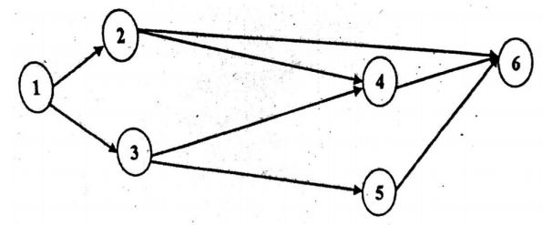
B.
Show all iterations and steps involved in the solution. Clearly show all the steps involved for arriving at the solution, starting from whether the problem is balanced or not. Find the optimal solution using MODI method.
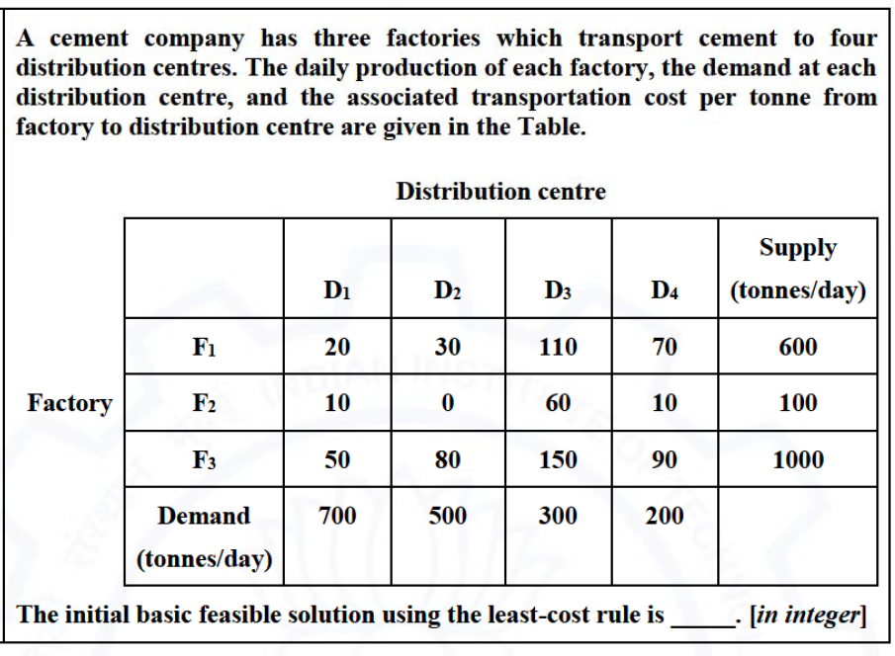

Problem #2 Total Points 20 (10) points for each sub part
- oints)
- A mining laboratory has two melts A and B comprising of copper (Cu), Nickel (Ni) and Zinc (Zn) alloy to make up a new alloy. The composition of metals are as follows for each Melt type.
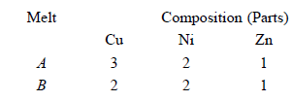
To make up a new alloy at least 15 kg of copper, 10 kg of nickel, and 6 kg of zinc are needed. Melt A cost Rs 45 per kg and Melt B cost Rs 50 per kg. Formulate the L.P.P. for the quantities of each melt to be used to minimized cost. Clearly define the decision variables and find the minimum cost using graphical or simplex method of your choice.

- Solve this assignment problem using Hungarian method. (10 points)
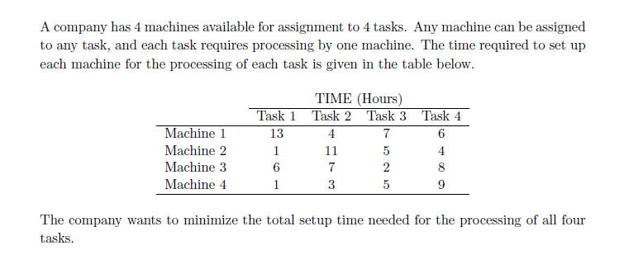

Problem #3 Total Points 20 (10) points for each sub part
- 10 points
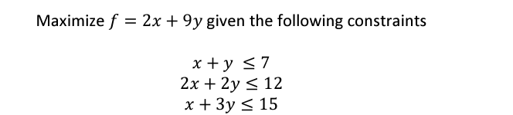
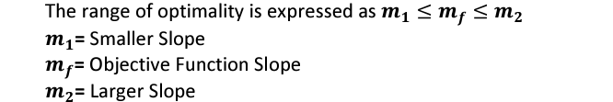
- Calculate RANGE OF OPTIMALITY of x AND 𝒚
- Find the Shadow Price for all constraints
- Find the Amount of Change in Objective Function if RHS of constraint (𝑥+3𝑦≤15) Increases by 8%

- 10 points (2) points for each sub part
Numerical data for an EPQ model are:
c – $0.40 per unit produced
c 0 – $5.40 per setup
c h – $0.072 annually per unit in inventory
D – 81,000 units demanded per year
P – 202,500 units produced per year
Lead time – 3 days / 250 working days per year

- Calculate the EPQ (Q*)
- Total relevant cost
- Total cycle time
- production time and depletion time
- reorder point

SECTION 2 ALL Questions are COMPULSORY (TOTAL MARKS 60)

Problem #4 Total Points (10) 5 points for each sub part
- What is the underloading and overloading problem of wagons in mines. List any 5 techniques to help improve this and how will this help CIL

- Roll a dice. If the side that comes up is odd, you win the $ equivalent of that side. If it is even, you lose $4. Find the expected value of X where is X is the random value of the dice

Problem #5 Total Points 5 points
Consider the following directed, weighted graph:
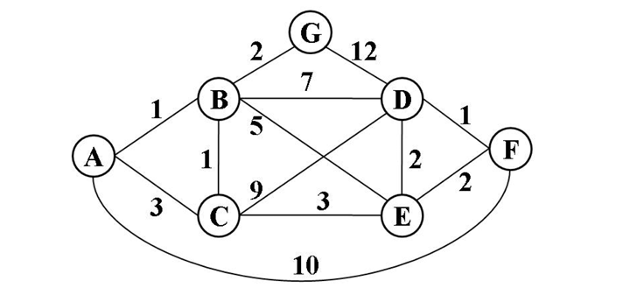
Use Dijkstra’s algorithm to calculate the single-source shortest paths from vertex A to every other vertex. Also list the vertices in the order which you marked them known. Finally, indicate the lowest-cast path from node A to node F. Also list the vertices in the order which you marked them known. Finally, indicate the lowest-cast path from node A to node F.

Problem #6 Points (20) 10 points for each sub part
Compute two minimum spanning trees for the following undirected, weighted graph
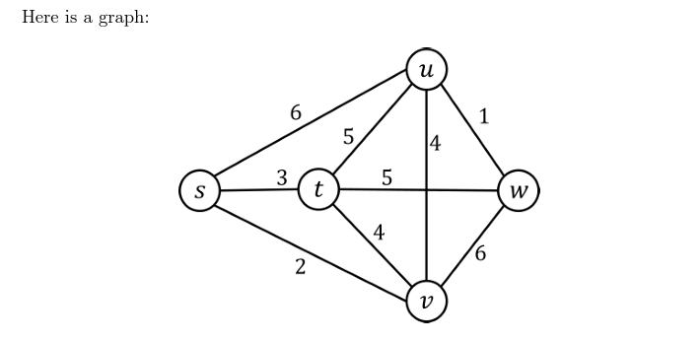
- Draw the minimum spanning tree that would result from running Prim’s algorithm on this graph, starting at vertex “s” List the order in which edges are added to the tree.
- Draw the minimum spanning tree that would result from running Kruskal’s algorithm on this graph. List the order in which edges are added to the tree. Show your steps at each iteration.
Problem #7 5 points
Thousands of items are held in inventory by a mine, but only a small % of them deserve management’s closest attention and tightest control. ABC is a production company. They use 10 different items in their production. The list of these items and some related data are given in the following table. Apply the ABC analysis and find the classes of the items.

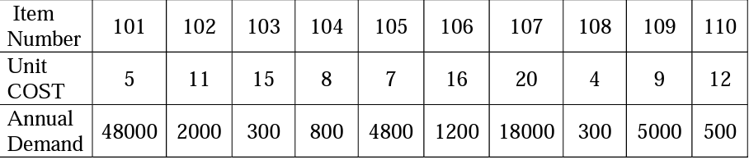
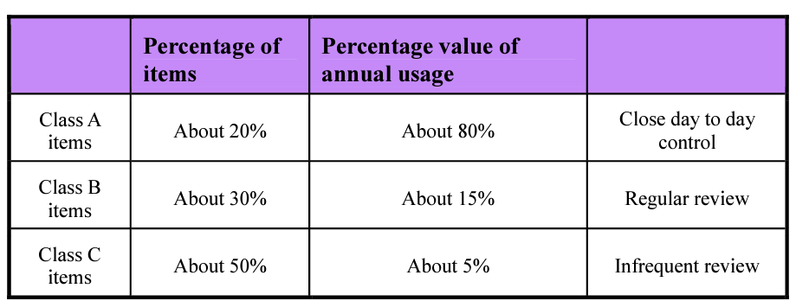
Clearly mention the results of each class and how you arrived at the solution.
Problem #8 Total Points (20)
Part a. Total Points (10) 2 points for each sub part
- Using the standard, no shortage model for EOQ calculate for the mine manager for ordering the items for inventory purposes based on following information:
- annual demand = 10,000 units/year
- Ordering cost = $10 per order
- Holding cost per year = 10% of item cost per unit
- Lead Time L = 10 days
- Cost per Unit C= $15
- No of Working Days = 365

- Determine Economic order quantity
- Total Cost
- Reorder Point
- Cycle Time & no of orders to be made in a year
- Calculate the practical Cycle time in days using the following rule
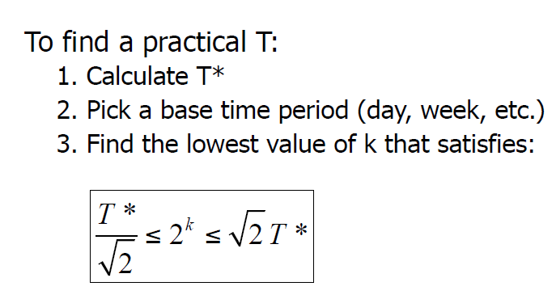
- EOQ Discount Qty model Total Points (10) 2 points for each sub part

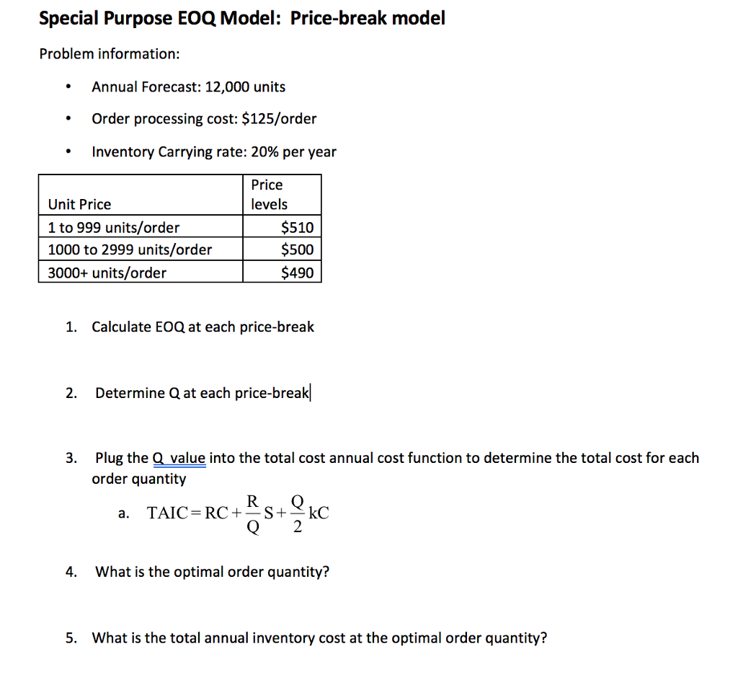
Draw the total cost curve vs. order quantity to explain your answer

List of formulae
Without shortage
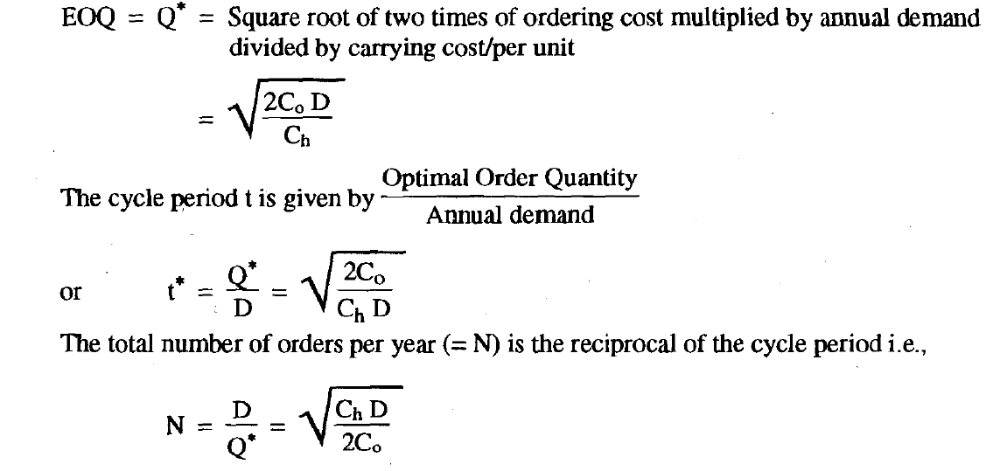
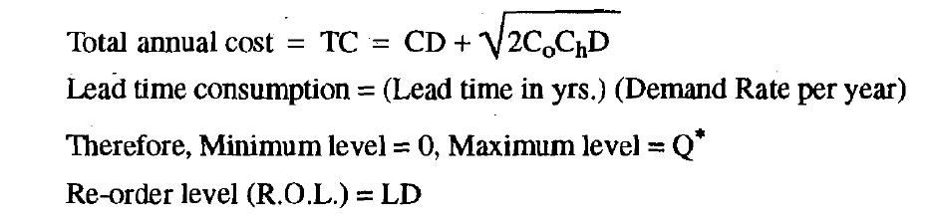

EPQ
